Lemington Riverside Primary School
Physical Development Progress Model for Knowledge and Skills
 | Minimum Expectations for Nursery |  |  |  | Minimum expectations for Reception |  |  |  |  | Links to KS1 curriculum
Dressing | Take off own coat.  Pull down pants to use toilet. |  | Put on shoes without fastening  (may be wrong  foot)  Pull zips up and down, but may need help to insert or separate zip. |  | Put/take own T-Shirt and jumper on/off independently but may be back to front.  Pull up garments on independently. |  |  | Put on socks and shoes correctly.  Fasten zip independently. | Dress and undress independently but may still need help with small buttons and laces.  Clothing may still be put on back-to front on occasion. | Fasten small buttons.  Tie own shoelaces.
Riding a bike | Uses feet to scoot a balance bike. | ‘Walks’ a balance bike. |  | Maintains balance while manoeuvring around corners. | Stops a bike effectively using brakes.  Pedals and maintains balance for a few feet down a slight incline. |  |  | Pedals and maintains balance for a few feet on a flat surface. | Pedals and maintains balance while manoeuvring around obstacles. | Brakes at a specific point with control  Follows at a sensible distance  behind another rider.  Controls speed in a group.  Follows a path set by another rider.
Ball Skills | Begins to throw ball. |  | Throws ball underhand/overhand. |  |  | Hits 2ft target with a small ball using underhand toss. |  | Usually hits a target from 12ft away using an overhand toss |  | Throws with accuracy.
Pencil grip | Uses a palmer grip – holds pencil in a whole fist.  Uses a comfortable grip with good control when holding pens and pencils. |  | Uses a digital Pronate Grip- all finger are holding the pencil and the hand is facing down. |  | Uses a splayed 4-finger grip – holding the pencil with all 4 tips of their fingers and thumb. |  | Uses a basic tri-pod grip – the child has some control whilst using the pencil.  Uses a comfortable grip with good control when holding pens and pencils.  Shows a preference for a dominant hand. | Develops the foundations of a handwriting style, which is fast, accurate and efficient. | Uses a basic tri-pod grip – using it correctly and with control. | Uses a mature/ dynamic tripod grip - holding the pencil between the thumb and index finger with pencil supported on the middle finger.
Scissors control | Uses one-handed tools and equipment, for example, making snips in paper with scissors.  Uses beginner scissors.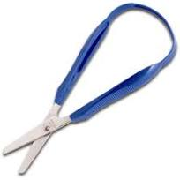 |  | Moves the scissors along the paper as they cut.  Uses scissors so an adult can help them.  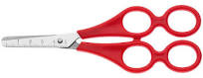 |  | Cuts to the end of a piece of paper.  Uses scissors without help of an adult.  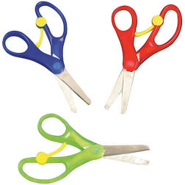 |  |  | Cuts out an object.  Independent scissors.  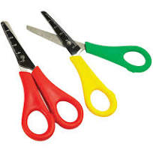 | Uses scissors competently, safely and confidently. | Becomes proficient in art, craft and design techniques.

